Assignment 7

Q1. Configure Static Routing Between Two Networks.
1. Create two routers, two switches, and four PCs in Cisco Packet Tracer.
2. Connect both routers through the 192.168.20.0/24 network.
3. Configure the LAN networks as 192.168.10.0/24 and 192.168.30.0/24.
4. Configure static routes on both routers using the respective next-hop IP addresses.
5. Verify the routing tables to confirm that static routes are configured correctly.

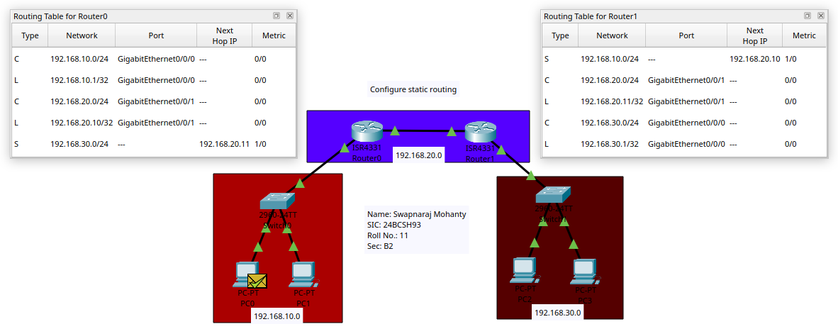

Q2. Configure Static Routing Across Multiple Routers.
1. Create four routers, two switches, and four PCs in Cisco Packet Tracer.
2. Connect the four routers in series using the 192.168.20.0/24, 192.168.30.0/24, and 192.168.40.0/24 networks.
3. Configure the end LANs with the network addresses 192.168.10.0/24 and 192.168.50.0/24.
4. Configure static routes on the routers to enable communication between the two end networks.
5. Verify the routing tables to ensure that the required static routes and next-hop addresses are correctly configured.

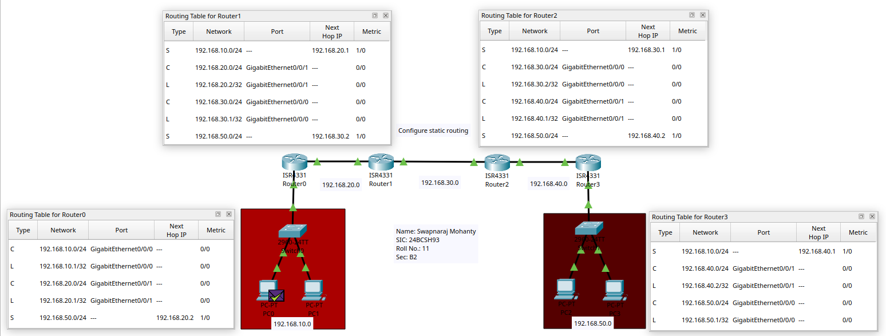

Q3. Configure VLANs Using a Switch.
- Create one Cisco 2960 switch and connect eight PCs to it in Cisco Packet Tracer.

2. Configure three VLANs using the following CLI commands:
Switch>enable
Switch#configure terminal
Switch(config)#VLAN 1
Switch(config-vlan)#exit
Switch(config)#VLAN 2
Switch(config-vlan)#exit
Switch(config)#VLAN 3
Switch(config-vlan)#exit

3. Assign switch ports Fa0/1–Fa0/3 to VLAN 1:
Switch(config)#interface range FA0/1-3
Switch(config-if-range)#switchport mode access
Switch(config-if-range)#switchport access VLAN 1
Switch(config-if-range)#exit

4. Assign switch ports Fa0/4–Fa0/6 to VLAN 2:
Switch(config)#interface range FA0/4-6
Switch(config-if-range)#switchport mode access
Switch(config-if-range)#switchport access VLAN 2
Switch(config-if-range)#exit

5. Assign switch ports Fa0/7–Fa0/8 to VLAN 3:
Switch(config)#interface range FA0/7-8
Switch(config-if-range)#switchport mode access
Switch(config-if-range)#switchport access VLAN 3
Switch(config-if-range)#exit

6. Exit the configuration mode using the following commands:
Switch(config)#exit
Switch#exit

- Verify the VLAN assignments using the Port Status Summary Table.

